Supervisor Incident/Accident Investigation Form
This form can be used as a tool to initiate the investigation of a hazard, hazardous occurrence, injury, or damage. If the matter has not already been reported to the University, a formal report must be submitted.

Supervisor
Name: ​​
Position / Role: ​
Department:
Phone:
Email: ​

Incident
Date:
Time:
Location:
Building & room:
Other:

Stakeholders (Injured Person, Witnesses, Facility Manager, etc.)
Add additional sections, as required.
Type:
Name:
Position / Role:
Department:
Other:

Type:
Name:
Position / Role:
Department:
Other:

Type:
Name:
Position / Role:
Department:
Other:

Injury Classification
Critical Injury  - places life in jeopardy (endangers a person's life);  - produces unconsciousness;  - results in substantial loss of blood;  - involves a fracture of a leg or arm, but not a finger or toe;  - involves the amputation of a leg, an arm, a hand or a foot, but not a finger or toe;  - consists of burns to a major portion of the body; or  - causes the loss of sight in an eye.  Immediately advise Protection Services at 613-562-5411 and advise that a person has sustained a critical injury. | Lost Time Injury  Means a worker cannot report for their next scheduled shift. Leaving the workplace during a work shift is not a lost time. |  | Injury Severity  1 – Slight or no injury; minor first aid; no impact on individuals  2 – Minor injury; no lost time  3 – Significant injury or illness, less than 14 days lost time; permanent disability not anticipated  4 – Serious injury or illness; more than 14 days’ lost time; permanent disability not anticipated  5 – Fatality; body part loss; life threatening situational exposure; serious permanent disability anticipated
Critical Injury (Yes or No)
Lost Time Injury (Yes or No)
Injury Severity (1 = least severe; 5 = most severe)
First aid administered (Yes or No)
Was medical attention required (Yes or No)
Name of doctor
Address of clinic / office / hospital

Injury Location
Indicate on the diagram which body parts were injured.

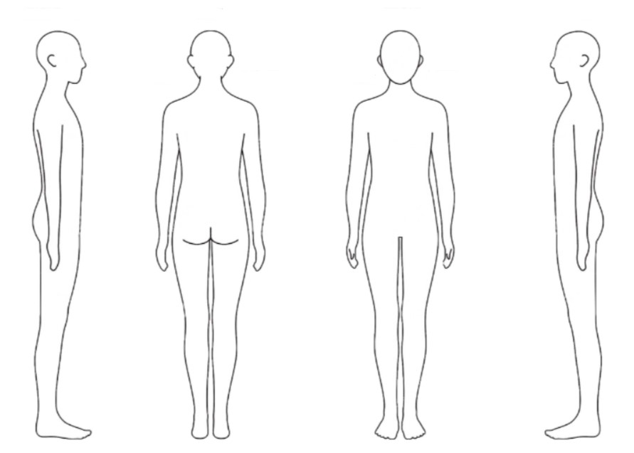

Body Parts
Indicate each body part that was injured.
Head |  | Upper Arm
Ear(s) |  | Elbow
Eye(s) |  | Lower Arm
Facial Bones |  | Hand(s)
Nose |  | Wrist
Brain |  | Finger(s)
Skull |  | Abdomen (including groin)
Teeth |  | Buttocks
Mouth |  | Hip
Soft Tissue - Head |  | Upper Leg
Neck |  | Knee
Throat |  | Lower Leg
Upper Back Area |  | Foot
Lower Back Area |  | Ankle
Pelvis |  | Toe(s)
Chest/Ribs |  | Whole Body
Shoulder(s)

Injury Details
List and describe injuries (e.g., scrape and bruise to outside of left elbow)

Incident Details
Indicate each incident type that occurred.
Assault / Violent act by animal |  | Contact with temperature extremes
Assault / Violent act by a person(s) |  | Exposure to air pressure changes
Bullying / Harassment / intimidation |  | Exposure to chemical agent
Self inflicted injury |  | Exposure to biological agent
Threat of violence |  | Exposure to designated substances
Bodily conditions |  | Exposure to noise
Bodily reaction |  | Exposure to radiation
Overexertion |  | Exposure to traumatic or stressful event
Repetitive motion |  | Oxygen deficiency
Static posture without the application of force to an object |  | Fire and explosion
Sustained viewing |  | Fall on same level
Caught in and compressed by equipment or object |  | Fall on lower level
Caught in or crushed in collapsing materials |  | Jump to lower level
Rubbed or abraded by friction or pressure |  | Slip/trip/fall on same level
Rubbed, abraded, or jarred by vibration |  | Slip/trip/fall on lower level
Struck against object |  | Pedestrian struck by a vehicle or mobile equipment
Struck by object |  | Transportation accident
Contact with electrical equipment |  | Other

Description of Incident Details
Describe the incident giving rise to the report. Describe the scene in detail. Add additional sections, as required.
- What was being done immediately prior to, at the time of, and after the incident.
- Note the environmental conditions (e.g., wet, dry, hot, cold, windy, dark, light, etc.)
- Record the equipment present / involved, the state of the equipment (e.g., damaged, broken, rusty, sharp, hot, properly located, etc.)
- List of hazardous materials involved, including chemical and biological substances.
- Include any information that will help with understanding the event and the outcome.

Contributing Factors
Select as many contributing factors as are relevant. The list below is not exhaustive and represents only a snapshot of potential contributing factors, many of which may fall into multiple causal categories.
Material | Environment | Personnel | Management | Task
​​☐​ Equipment failure | ​​☐​ Weather conditions | ​​☐​ Training | ​​☐​ Policies | ​​☐​ Work conditions
​​☐​ Equipment design | ​​☐​ Housekeeping | ​​☐​ Fitness for work | ​​☐​ Procedures | ​​☐​ Work technique
​​☐​ Hazardous materials | ​​☐​ Temperature | ​​☐​ Stresses | ​​☐​ Enforcement | ​​☐​ Tools/equipment
​​☐​ Loading | ​​☐​ Noise | ​​☐​ PPE | ​​☐​ Supervision | ​​☐​ Storage
​​☐​ Lifting | ​​☐​ Lighting | ​​☐​ Contravention | ​​☐​ Hazard identification | ​​☐​ Process design
 | ​​☐​ Contaminants | ​​☐​ Authorization | ​​☐​ Maintenance | ​​☐​ Speed
 | ​​☐​ Obstructed view | ​​☐​ Acts of others | ​​☐​ Inspections
 | ​​☐​ Slippery surfaces |  | ​​☐​ Work schedule
 | ​​☐​ Ventilation
​​☐​ Other ​___​_______

Contributing Factors Descriptions
Record any pertinent details to help understand the factors contributing to the incident.

Witnesses
Identify the witness(es) by name, role, department, email / phone, etc. It is best to speak with witnesses separately and as soon as possible thereafter the incident.

Have witnesses provide an account of the incident using appendix 2. Attach the statement(s) to this form. Review the statement with the witness to confirm understanding.

Immediate actions taken:
List the immediate actions implemented to address the incident.

Causes:
What was the cause of the incident?

Recommendations:
What are the recommendations to prevent a recurrence?

Corrective Actions
What are the necessary actions to follow to prevent a recurrence?
Action | Responsible Person | Deadline

Signatures:
Role | Name | Signature | Date
Investigator:
Supervisor:
Committee Member:

Supervisor Role and Responsibilities
Once a hazard or accident has been identified, the primary responsibility of the supervisor is to protect the workers and ensure actions are taken to prevent a recurrence. The process to achieve this is known as accident investigation and is comprised of the following steps: Respond, Investigate, Report, Correct and Communicate.

What to Respond to
- A hazardous situation is identified
- An injury or illness has occurred
- Damage has occurred without injury

When to Respond and Investigate
- Immediately, protection of your people and prevention of recurrence are your primary responsibilities.

How to Respond, Investigate, Correct, and Communicate
- Protect the people involved:
  - Get first aid for injured persons. Record first aid actions.
  - Identify, assess, and protect from the hazards present.
- Secure the scene. Do not allow anyone to alter the scene unless it is to provide care or protection to a person or to respond to an emergency.
- Document the scene: make notes and (where relevant) take pictures of everything including all persons, equipment, materials, environment, processes and procedures involved, makes notes of location, condition, what was happening, what was supposed to happen, what did happen, etc.
- Record notes using Appendix 1.
- Interview all people involved separately and as soon as possible to understand what occurred.
- Workers involved can complete a witness statement using Appendix 2.
- Develop a list of existing conditions and contributing factors.
- Record all actions taken, including immediate and those for the longer term.
- Develop a list of causes.
- Develop and implement a list of corrective actions to prevent recurrence.
- All information must be included in the completed Accident, Incident, Occupational Disease or Near Miss Form (e.g., if available at time of submission or following the collection of the necessary information).
- Ensure that the necessary corrective actions are implemented.
- Ensure the report is submitted and distributed to the parties involved. Pictures, reports, test results or other supporting documentation may be included in the written report. You must communicate the results of the incident investigation to:
  - Persons affected by the incident (i.e., the worker(s) involved)
  - Department chair/manager (where applicable)
  - Faculty Health, Safety and Risk Manager (where applicable)
  - Office of the Chief Risk officer – Health and Safety Team (via sst-ohs@uottawa.ca)

Helpful Investigative Questions
The goal is to discern what should have occurred and what occurred, the differences between these two pieces of information, will become the basis for contributing factors and causes.
- Who was involved, including the name, title, and role
- Was a similar incident previously identified or reported? What were the root causes and corrective actions? Were they implemented? Were they effective?
- What is the correct equipment? Was it used? Was it used properly? Was the person trained to use it? Has it been inspected? Is it certified? Is it in good working order? Are there maintenance records?
- Is the work environment safe? Air, lighting, noise, temperature, organised, messy, dry, wet…etc.
- Has the worker been made aware of the hazards relating to the work? Has the worker been trained to perform the task? Were there distractions? Is the worker fit for work? What was the workers work schedule? How much experience does the worker have?
- Was personal protective equipment (PPE) was used? Was it the correct PPE? Was the worker trained to use the PPE? Was the PPE maintained properly?
- Was the worker rushed? Is the worker under pressure to perform / deliver?
- Is there a policy relating to the work? Is it followed? Is it enforced? What is the correct procedure? Was it followed?
- Who verifies the work is being done correctly in this workplace? Are there records of assessment and correction of workplace activities?
- What has been, or will be, done to prevent a reoccurrence of the accident, incident, or occupational illness? Explain in detail the proposed (or current) corrective actions.
- Who is responsible for implementing the corrective action(s)?
- When can corrective actions be expected to be implemented?
- Is there a requirement to engage supporting expertise (e.g., for workplace testing, consultations, etc.)?

References and Tools
- Incident Reporting Procedure
- Accident, Incident, Occupational Disease or Near Miss Form
Required to contact:
- Faculty Health, Safety and Risk Manager (They will guide and support you through this process, if your faculty or service has one on staff)
- Protection Services - If a critical injury or injury requiring further medical assistance has occurred, contact Protection Services at ext. 5411.
- Health and Wellness - If a worker cannot report for their next scheduled full shift of work / return to work plan.
- Office of the Chief Risk Officer - Health and Safety Team (via sst-ohs@uottawa.ca) – for all hazardous occurrences, accidents, and incidents.

APPENDIX 1 – INVESTIGATOR NOTES AND DETAILS
Date: _______________________________________________________________________________________
Time: _______________________________________________________________________________________
Location: ___________________________________________________________________________________
People: ____________________________________________________________________________________________ ____________________________________________________________________________________________________________________________________________________________________________________________________________________________________________________________________________________________________________________________________________________________________________________

Details:
___________________________________________________________________________________________________________________________________________________________________________________________________________________________________________________________________________________________________________________________________________________________________________________________________________________________________________________________________________________________________________________________________________________________________________________________________________________________________________________________________________________________________________________________________________________________________________________________________________________________________________________________________________________________________________________________________________________________________________________________________________________________________________________________________________________________________________________________________________________________________________________________________________________________________________________________________________________________________________________________________________________________________________________________________________________________________________________________________________________________________________________________________________________________________________________________________________________________________________________________________________________________________________________________________________________________________________________________________________________________________________________________________________________________________________________________________________________________________________________________________________________________________________________________________________________________________________________________________________________________________________________________________________________________________________________________________________________________________________________________________________________________________________________________________________________________________________________________________________________________________________________________________________________________________________________________________________________________________________________________________________________________________________________________________________________________________________________________________________________________________________________________________________________________________________________________________________________________________________________________________

APPENDIX 2 – WITNESS STATEMENT

Name: _____________________________________________________________________________
Role: ____________________________________________________________________________________________
Contact: ____________________________________________________________________________________________
Date and Time: ____________________________________________________________________________________________

Details:
____________________________________________________________________________________________________________________________________________________________________________________________________________________________________________________________________________________________________________________________________________________________________________________________________________________________________________________________________________________________________________________________________________________________________________________________________________________________________________________________________________________________________________________________________________________________________________________________________________________________________________________________________________________________________________________________________________________________________________________________________________________________________________________________________________________________________________________________________________________________________________________________________________________________________________________________________________________________________________________________________________________________________________________________________________________________________________________________________________________________________________________________________________________________________________________________________________________________________________________________________________________________________________________________________________________________________________________________________________________________________________________________________________________________________________________________________________________________________________________________________________________________________________________________________________________________________________________________________________________________________________________________________________________________________________________________________________________________________________________________________________________________________________________________________________________________________________________________________________________________________________________________________________________________________________________________________________________________________________________________________________________________________________
Signature: __________________________________________________________________________________

